Install SuiteCloud Extension for visual studio code on VSCODE
Download extensions from java on VSCODE:
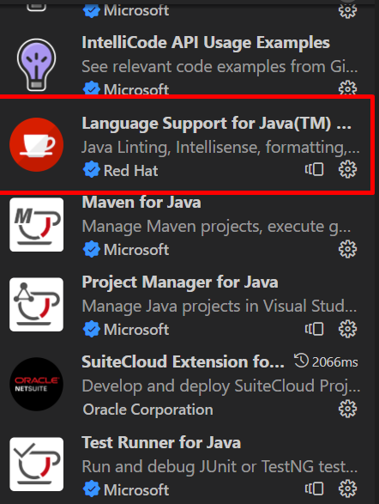
Be careful with this one, it adds you adoptium with java jdk hotspot version 11, we need version 17, so we remove adoptium and then download from adoptium webpage open jdk version 17:
Install openJDK17U-jdk hotspot from https://adoptium.net/es/download

Update bundle:
Command palette: y escribo set up account
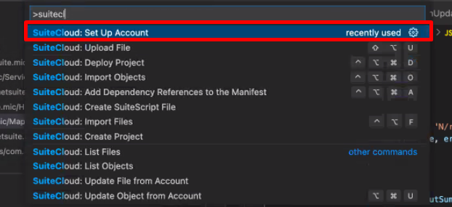
Y luego upload file.

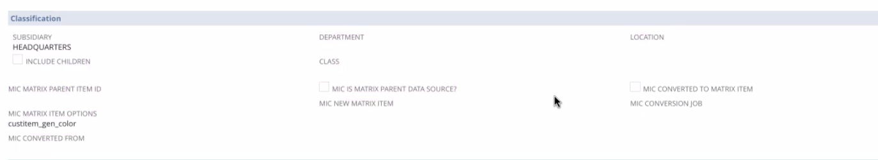
Have the fields automatically show after bundle install.
After we install the bundle, this custom item fields should appear on items.
quantityToAdjustOldItemBy: result.getValue(mySearch.columns[3]) * -1,
cambiarlo eliminando el -1 porque ya esta negado en su search.
Customization -> SuiteBundler -> Create Bundle -> List y presiono en el tipito verde, y edit.
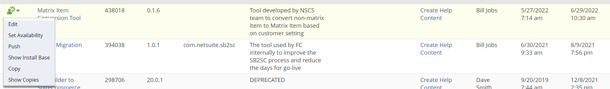

- All the custom item MIC fields don’t show on the item record after installing the bundle. Can you have it to where they will show on the item record in the main area after installing the bundle?
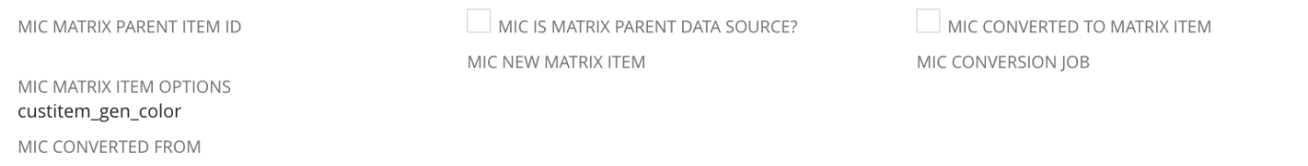
MIC MATRIX PARENT ITEM ID
MIC IS MATRIX PARENT DATA SOURCE?
MIC CONVERTED TO MATRIX ITEM
MIC NEW MATRIX ITEM
MIC CONVERSION JOB
MIC MATRIX ITEM OPTIONS
MIC CONVERTED FROM

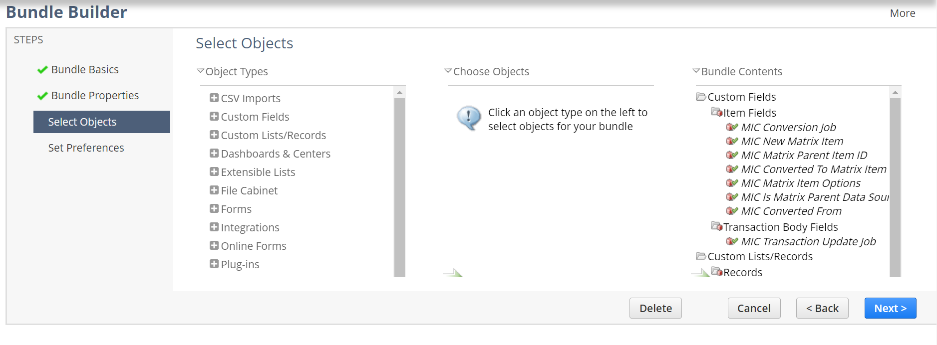
Aparecen pero capaz estan en hide.
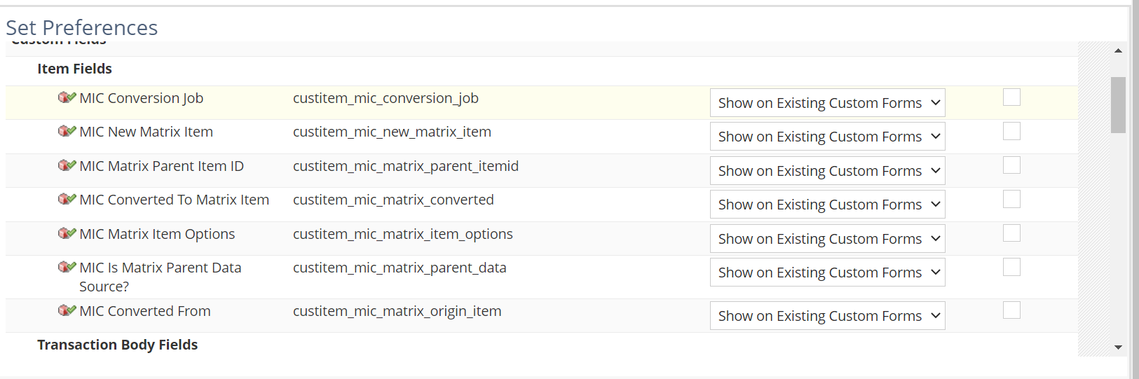Acá lo pongo, pero después en la instalación pueden cambiarlo ellos.
Esto es un cambio en el bundle, luego ellos tienen que actualizarlo en sus cuentas.

- I made some updates to the search “MIC Matrix Item Conversion Inventory Adjustments” can you push these updates to the bundle? customsearch_mic_inv_adjustment
La busque en el código y no esta.
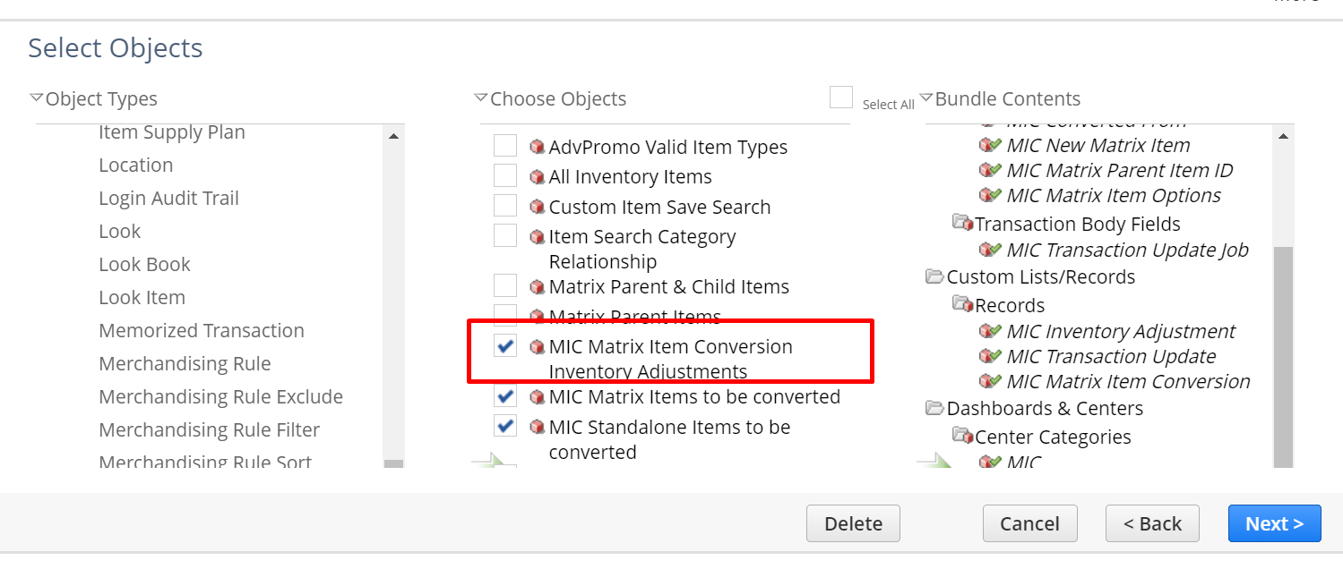
Ya estaba en el bundle, guardarlo nomas.

- I made an update to the code in the MIC Inventory Adjustment Map Reduce script which was updating this line of code “quantityToAdjustOldItemBy: result.getValue(mySearch.columns[3]) * -1” to “quantityToAdjustOldItemBy: result.getValue(mySearch.columns[3])”. Can you push this update to the bundle?
El save anterior me acutalizo el bundle.
- I made an update to the script deployment “MIC Inventory Adjustment Map Reduce” by updating the parameters from:
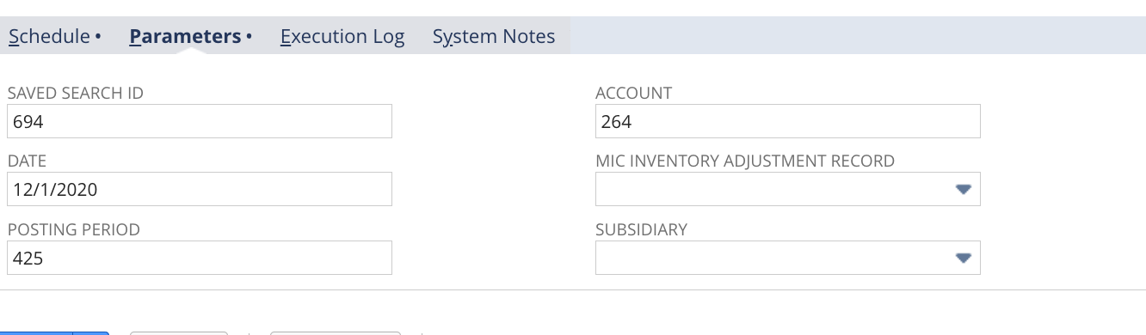
To
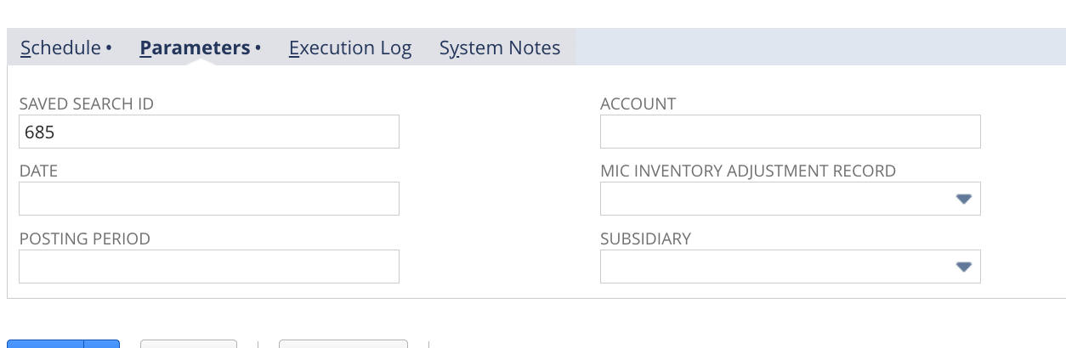
Can you push this update to the bundle?
